24.50: a) 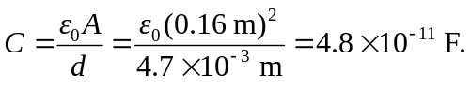
b)
c) E=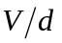=(12 V)/(4.7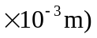=2553 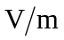.
d)
e) If the battery is disconnected, so the charge remains constant, and the plates are pulled further apart to 0.0094 m, then the calculations above can be carried out just as before, and we find:

a) 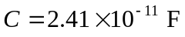 b) 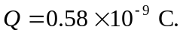
c) 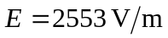 d) 